FLO MOBILITY
Homepage SEO Optimisation — Suggested Changes
Based on the live flomobility.com homepage (screenshots reviewed 27 July 2026). Every rewrite below preserves the existing layout, section order and design — only copy, tags and metadata change.
How this document is organised
Each change is one of two types. MUST-FIX items are defects — missing tags, broken semantics or factual gaps that actively cost rankings. RECOMMENDED items are copy and structure upgrades that compound over time. Copy rewrites are shown as Current → Ship this, matched in length wherever possible so nothing reflows on screen.

1. Page title & meta description
MUST-FIX
The homepage is currently indexing as "Flo Mobility | Autonomous Robots for Construction and Industrial Sites" — 70 characters, which Google truncates in the search snippet at roughly "…for Construction and Indu…". It also never mentions India, despite India being Flo's only market and the qualifier on six of the highest-priority target keywords ("construction robotics India", "largest construction robotics company India", etc.).
CURRENT | SHIP THIS
Title Flo Mobility | Autonomous Robots for Construction and Industrial Sites (70 characters — truncates) | Construction Robots India | Flo Mobility (40 characters)
Description Flo Mobility deploys autonomous robots for construction and industrial sites, including material movement robots and fleet control software. (139 characters) | India's largest construction robotics company. Autonomous material movement robots and electric wheelbarrows that cut site costs. 50+ deployed. No capex.

Also confirm:
- Canonical tag is present and points to https://flomobility.com — keep it, but standardise on the non-trailing-slash form sitewide.
- og:image stays as the current fleet lineup image; it already reads well as a social card.

2. Give the homepage an actual H1
MUST-FIX
The homepage has no H1
The hero headline "Autonomous / construction / at scale." currently renders as three separate H2 elements. There is no H1 anywhere on the page. Google's own Key Best Practices name the main heading as one of the two most important places to put the words people search for — and the most important page on the site isn't using it.
The fix is a wrapper-tag change only. Wrap the whole headline in one heading element and make each visual line a span with display:block — identical rendering, correct semantics:
Ship this:
<h1 class="hero-title">
<span>Autonomous</span>
<span>construction robots</span>
<span>at scale.</span>
</h1> /* .hero-title span { display: block; } */
Note the headline copy itself also changes slightly — "construction" becomes "construction robots" — see Section 3 below; that's the only text change bundled with this fix.

3. Hero section copy
RECOMMENDED
Small, length-matched additions that put the exact target phrase into the H1 and the supporting line, without changing the design or the sentence rhythm the designer built.
CURRENT | SHIP THIS
H1 Autonomous / construction / at scale. (37 characters) | Autonomous / construction robots / at scale. (44 characters, +7)
Supporting line Autonomous robots deployed on-site as a service. Haul materials, maintain grounds, control your fleet. No capital cost, no infrastructure changes. (146 characters) | Autonomous construction robots deployed on-site as a service. Haul materials, control your fleet, move faster. No capital cost, no infrastructure changes. (154 characters, +8)

Autoplay video is likely the biggest performance win on the page
If the hero embed loads with autoplay=1&mute=1, it competes for bandwidth and main-thread time at exactly the moment the browser is trying to paint — on a page whose audience is disproportionately on a phone on a job site. Switch to a click-to-play thumbnail, the same pattern already used correctly on the Fleet Control page. Likely the single largest LCP/INP win available on this page.

4. Mission section ("Autonomous construction at scale")
RECOMMENDED
Same three-sibling-heading pattern as the hero — confirm it's fixed to one H2 with spans (see Section 2 pattern) and apply the equivalent keyword-carrying copy update to the supporting paragraph:
CURRENT | SHIP THIS
Autonomous robots deployed on-site as a service. Haul materials, maintain grounds, control your fleet. No capital cost, no infrastructure changes. | Autonomous construction robots deployed on-site as a service. Haul materials, control your fleet, move faster. No capital cost, no infrastructure changes.

5. "Our Fleet" section
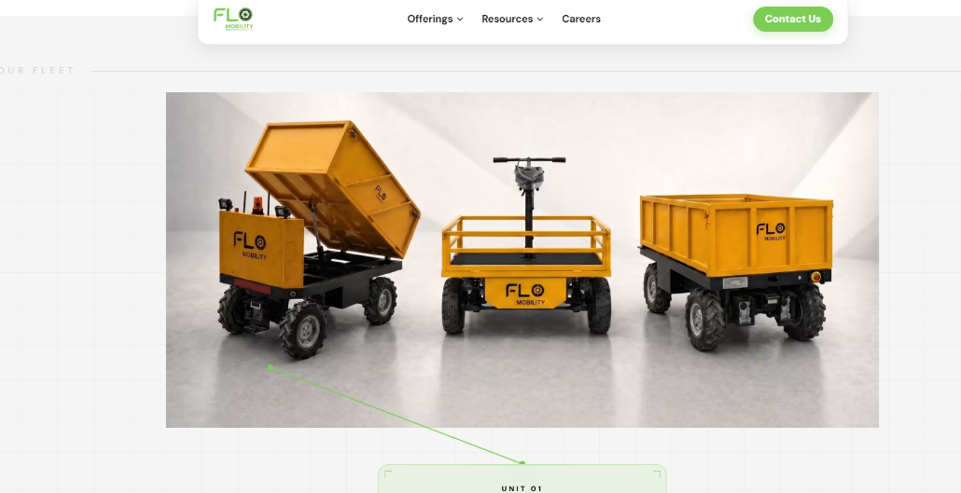
RECOMMENDED
Image file name: flo-mobility-autonomous-electric-wheelbarrow-remote-controlled-pushcart-construction-robots-india.webp
Alt text: Flo Mobility autonomous electric wheelbarrow, remote controlled electric wheelbarrow and 1 ton pushcart for construction sites.
Unit 01
Autonomous Electric Wheelbarrow
GPS & LiDAR-powered for autonomous material movement.
Unit 02
1 Ton Electric Pushcart
High-capacity electric cart for heavy material transport.
Unit 03
Electric Wheelbarrow
Remote-operated for precise material movement.

The three-unit fleet showcase (Autonomous Cart and siblings) is a strong visual asset but currently carries only short unit labels. Two low-effort additions:
- Add one line of descriptive copy per unit (payload, use case) — this is unique, specific content Google can actually index, versus a label alone.
- Make sure each unit card links through to the relevant offering page (Material Movement / Fleet Control) with descriptive anchor text — see Section 9, internal linking.

6. "Powering India's largest projects" (Customers)
RECOMMENDED
CURRENT | SHIP THIS
15+ companies. India's largest construction sites. Measurable ROI from day one. (79 characters) | 15+ developers, EPC and infra firms. India's largest sites. Measurable ROI from day one. (88 characters, +9)

Put the strongest SEO asset on this page, not just in the footer
"India's largest construction robotics service provider" currently only appears in the sitewide footer. It's a direct, ownable answer to two high-value commercial keywords: "largest construction robotics company India" and "construction robotics companies India". Add it as a visible statement near this Customers section, with a dated methodology line: "India's largest construction robotics service provider, by active robot fleet size as of July 2026." A superlative with a stated basis is citable and defensible; one without it is just marketing copy.

Logo image alt text (all customer logos, 25 total):

Company | SEO Alt Text
L&T | L&T, Flo Mobility construction robotics customer
Godrej | Godrej, Flo Mobility construction robotics customer
Kalpataru | Kalpataru, Flo Mobility construction robotics customer
Embassy | Embassy Group, Flo Mobility construction robotics customer
Sobha | Sobha, Flo Mobility construction robotics customer
Al Gurg Group | Al Gurg Group, Flo Mobility construction robotics customer
Nissan | Nissan Motor Corporation, Flo Mobility construction robotics customer
KEC | KEC International, Flo Mobility construction robotics customer
ASBL | ASBL, Flo Mobility construction robotics customer
Ahluwalia Contracts | Ahluwalia Contracts, Flo Mobility construction robotics customer
Capacite | Capacite Infraprojects, Flo Mobility construction robotics customer
TARC | TARC, Flo Mobility construction robotics customer
Sowparnika Projects | Sowparnika Projects, Flo Mobility construction robotics customer
Runwal | Runwal Group, Flo Mobility construction robotics customer
Total Environment | Total Environment, Flo Mobility construction robotics customer
Shriram Properties | Shriram Properties, Flo Mobility construction robotics customer
Leighton | Leighton, Flo Mobility construction robotics customer
Kolte Patil | Kolte Patil Developers, Flo Mobility construction robotics customer
M3M | M3M India, Flo Mobility construction robotics customer
PSP Projects | PSP Projects, Flo Mobility construction robotics customer
Century | Century Real Estate, Flo Mobility construction robotics customer
K2K Infrastructure | K2K Infrastructure, Flo Mobility construction robotics customer
UPL | UPL, Flo Mobility construction robotics customer
Emboss | Emboss Construction, Flo Mobility construction robotics customer
Hi-Tech | Hi-Tech Construction, Flo Mobility construction robotics customer

Performance note: 32 logo images load below the fold on this page. Confirm loading="lazy" is set on all of them (only the hero image should load eager, with fetchpriority="high"), and that they're served at their rendered display size rather than scaled down via CSS from a much larger source file.

7. "Fueling our growth and innovation" (Investors)
RECOMMENDED
Lower priority than the customer logos since this section targets brand/trust signals rather than a P1 keyword, but apply the same fixes for consistency:
- Same three-sibling-heading pattern likely applies to "Fueling our growth and innovation." — wrap as one H2.
- Investor logo alt text: "[Fund name], Flo Mobility investor" instead of the fund name alone.
- Same lazy-loading treatment as the customer logo row.

8. Closing CTA ("Ready to automate your site?") and footer
MUST-FIX + RECOMMENDED
CURRENT | SHIP THIS
Autonomous robots on a flexible subscription — no capital cost, deployed in days. (81 characters) | Construction robots on a flexible subscription, no capital cost, deployed in days. (82 characters, +1)

Footer defects to fix on this page (they render sitewide, but the homepage is the highest-traffic instance):
Footer link | Currently resolves to | Must resolve to
Privacy Policy | /contact | https://drive.google.com/drive/folders/1gx_Wr_c6Xq50kVBBEJnBme3ByVVDQTZN?usp=sharing
Terms of Use | /contact | https://drive.google.com/drive/folders/1gx_Wr_c6Xq50kVBBEJnBme3ByVVDQTZN?usp=sharing

Every enterprise buyer running a vendor security review who clicks "Privacy Policy" and lands on a lead-gen form is a stalled procurement conversation. This is a one-line link fix plus creating /terms.

Footer navigation is under-built for a page this valuable:
Column | Today | Ship this
Offerings | Material Movement, Fleet Control | Electric Wheelbarrow, Fleet Control
Company | About, Careers, Blog, Contact | About, Careers, Blog, Contact

The footer is on every page and crawled on every page — it's the cheapest internal-authority distribution mechanism on the site and it's currently half empty.

9. Internal linking from the homepage
RECOMMENDED
Anchor location | Anchor text | Links to
Hero deck (after Section 3 copy update) | Haul materials | /offerings/material-movement
Technology / stack section | fleet software | /offerings/fleet-control
"See how it works" CTA | See how it works (relabel if it stays pointed at /contact) | /offerings/material-movement, or relabel to "Book a Demo"

Fix the misleading CTA now
"See how it works" currently links straight to the /contact form, not to anything explaining how it works. That's a mismatch between anchor text and destination. Either point it at /offerings/material-movement or relabel it to match the button beside it.

10. Header navigation
MUST-FIX
"Offerings" and "Resources" render as dropdown triggers in the header on every page including the homepage. Confirm via View Source (not DevTools, which shows the hydrated DOM) that /offerings/material-movement and /offerings/fleet-control exist as real anchor tags in the initial HTML — if they only appear on hover or click, the two commercial pages are receiving sitewide internal links from the footer only.
"Resources" currently has no discoverable destination anywhere on the crawled site. Either point it at /blogs today or build a proper /resources hub. A nav label that goes nowhere is a dead slot in the most valuable template on the site.

11. Structured data (JSON-LD) for the homepage
RECOMMENDED
This is the highest-leverage schema addition on the entire site
Third-party databases have already absorbed Flo's retired lawn-care history — Tracxn currently describes Flo as a developer of robots for "material movement, lawn care, and finishing," and CB Insights lists "lawn maintenance and agricultural" as core sectors. Organization and WebSite schema on the homepage is the most direct, low-effort way to correct that entity confusion for Google and for any AI system reading Google's index.
- Organization schema: name, logo, sameAs (social profiles), description matching the corrected meta description.
- WebSite schema with a SearchAction if the site has internal search.
- Only mark up content that is genuinely visible on the page — no fabricated ratings, no FAQ schema until an actual FAQ section exists on the page.
Verify with Google's Rich Results Test after shipping.

12. Reconcile the numbers used on this page
MUST-FIX
The homepage's own stats contradict numbers used elsewhere on the site
"50+ robots deployed" and "32 Projects Expedited" appear on the homepage, but /offerings/material-movement states "70+" deployed and /channel-partner states "200+ Active Deployments" and "200+ Projects completed." A search quality rater — and a careful enterprise buyer — will notice inconsistent numbers on the same domain. This needs a decision from leadership on the true current figure, not a developer fix.
Claim | Homepage | Elsewhere on site
Robots deployed | 50+ | 70+ (Material Movement) · 200+ "Active Deployments" (Channel Partner)
Projects | 32 Projects Expedited | 200+ projects completed (Channel Partner)

Once reconciled, publish the number as a dated, sourced statement rather than a bare figure — e.g. "50+ robots currently deployed across 32 active sites as of July 2026." That specificity is exactly the kind of statement AI Overviews and featured snippets tend to pull directly.

Priority order for this page
# | Change | Type | Effort
1 | Title & meta description rewrite | Must-fix | 30 min
2 | Single H1 wrapping the hero headline | Must-fix | 1 hr
3 | Privacy/Terms footer links + create /terms | Must-fix | 2 hrs
4 | Confirm Offerings/Resources are real anchor tags, not hover-only | Must-fix | 30 min (verify)
5 | Reconcile deployed/projects numbers with leadership | Must-fix | Decision, then 30 min
6 | Hero + mission + closing CTA copy rewrites | Recommended | 1 hr
7 | Click-to-play instead of autoplay video | Recommended | 2–3 hrs
8 | Logo alt text (32 images) + lazy loading | Recommended | 2 hrs
9 | Internal links to offering pages + fix "See how it works" | Recommended | 1 hr
10 | Organization + WebSite JSON-LD | Recommended | 2–3 hrs

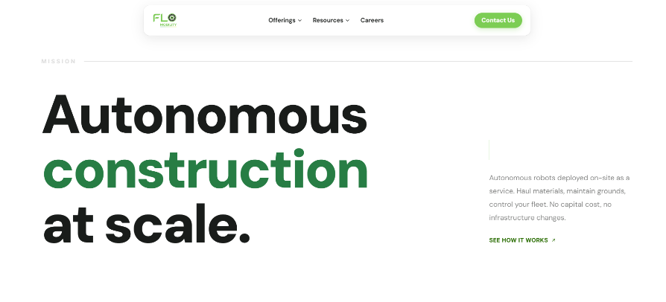
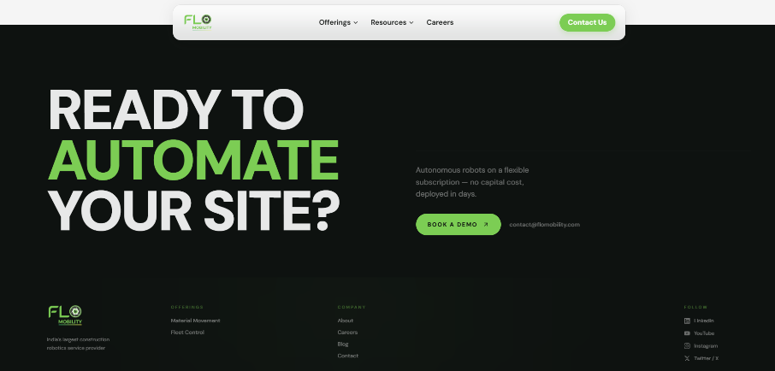
Increase the font to a readable size.

